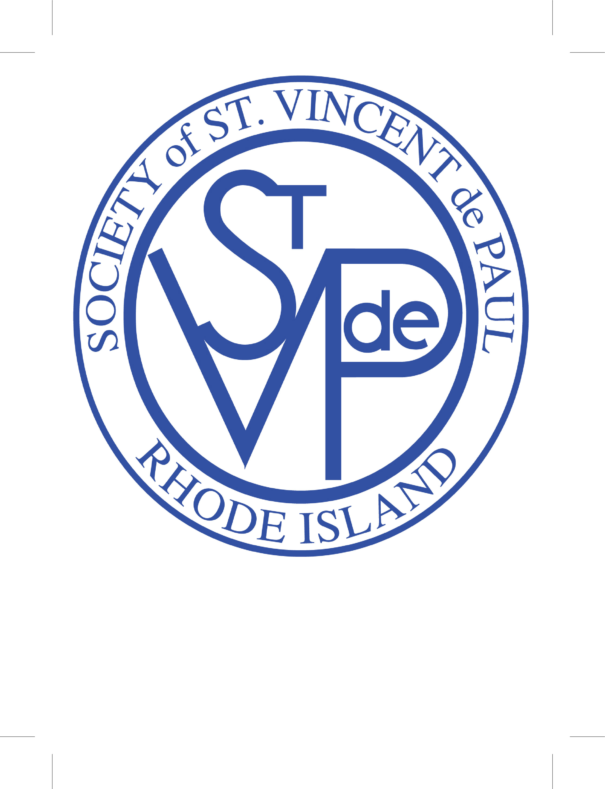
Society of St. Vincent de Paul (SVDP) Rhode Island
CODE OF ETHICAL CONDUCT
SVDP Rhode Island conferences, districts, offices, and agencies will maintain an environment that is free from all forms of intimidation and harassment: physical, verbal, written, psychological, social, and electronic.

SVDP Rhode Island conferences, districts, offices, and agencies will employ disciplinary practices that respect the dignity of each child. It is not acceptable to strike, shake or slap a child.

Adults will not provide a gift to an individual young person without prior approval from the administrator of the program.

Adults will meet with an individual young person and mentees in an open and public area.

Adults will not be alone with a young person or a mentee in a residence, sleeping facility, locker room, rest room, dressing facility or other closed room or isolated area.

Adults will not provide alcohol, controlled substances or pornographic materials to young people or mentees at any time.

Adults will not use or be under the influence of alcohol or controlled substances while participating in a youth or mentee activity. Adults or minors who are under the influence of alcohol or controlled substances are not permitted to participate in youth or mentee events. No alcoholic beverages will be accessible or served during events which are designed specifically for children.

Adults will not drive alone with a young person without explicit parental or guardian consent.

Adults will report the abuse or inappropriate activities involving a minor or mentee to appropriate personnel immediately.

Adults will cooperate fully with SVDP Rhode Island law enforcement personnel in any investigation of abuse of children and/or youth.

SVDP Rhode Island, P.O. Box 100265, Cranston, RI 02910 401-490-0822 X113 www.svdpri.org

