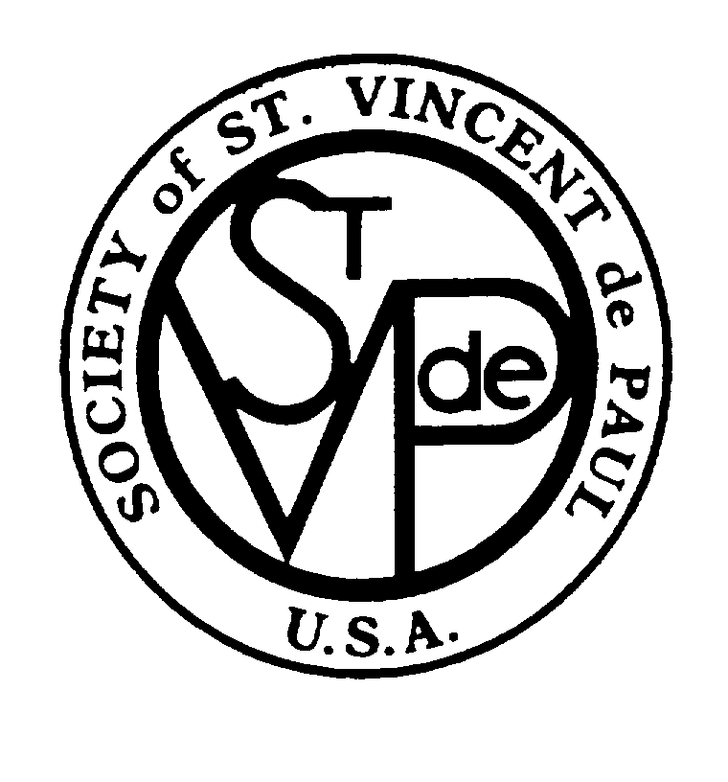

SOCIETY OF ST. VINCENT DE PAUL

SPIRITUAL ADVISOR
GUIDELINES
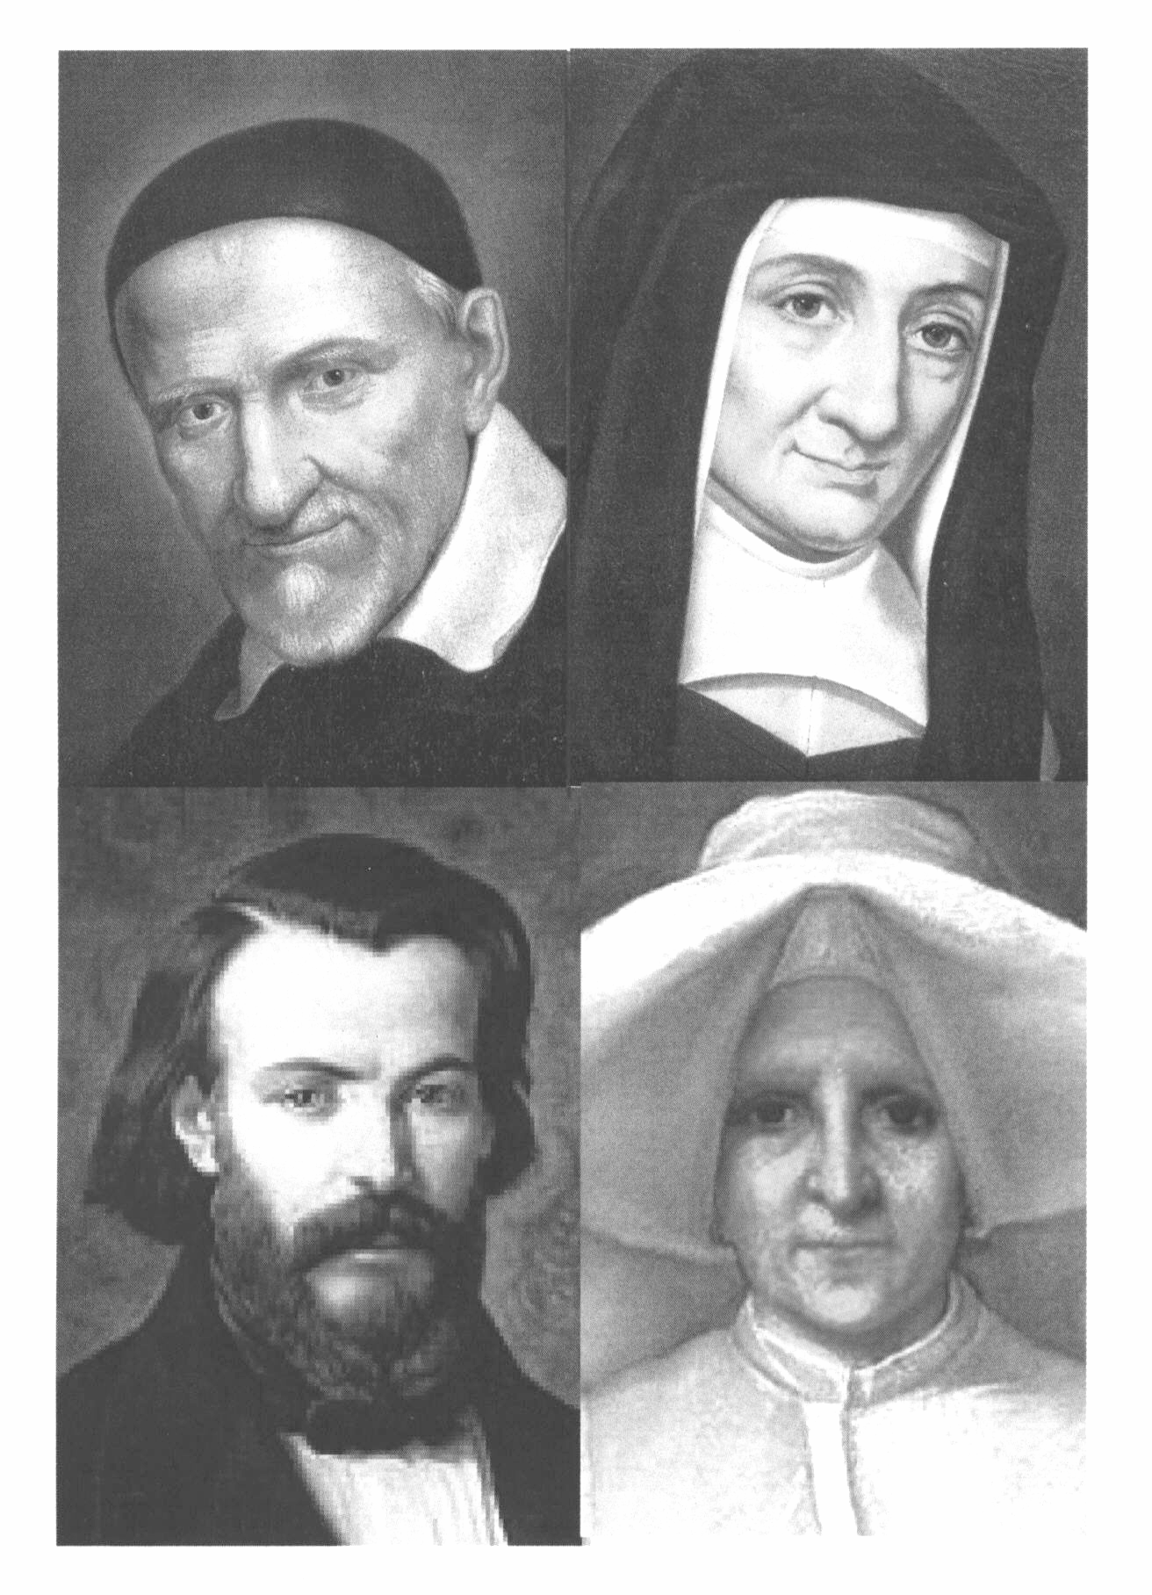

“Roles and Responsibilities”

REGION
COUNCIL
CONFERENCE

Approved: April 2012

INTRODUCTION

The Rule 3.13 states:

“Members of the Society are united in the same spirit of poverty

and sharing. They encourage one another to live a profound

spiritual life and spirit of prayer. For this purpose, the role of

SPIRITUAL ADVISOR IS VERY IMPORTANT.”

To grow in holiness:

The purpose of the Society of St. Vincent de Paul is to increase the holiness of its members, and so from its foundation the Society has affirmed the importance of the role of Spiritual Advisor as being essential to its life and mission. The Spiritual Advisor is responsible for the spiritual development of either a Region, Council or a Conference. This requires a solid knowledge of the Catholic faith and a full knowledge of and dedication to the mission and ministry of the Society, which is inclusive of evangelizing the poor and being evangelized by the poor.

Goal 1 of the Strategic Plan of the Council of the United States is dedicated to “ Enable spiritual growth and leadership development throughout the Society.”Objective 1.2 states “Spiritual Advisor: cultivate an active and formed lay, ordained and/or religious for every Council, Conference and Special Work.” The Region, Council or Conference leadership, therefore, has the obligation to select a Catholic person who is both willing and able to devote the necessary time and energy to the role of Spiritual Advisor. It is imperative that Spiritual Advisors be rooted in Vincentian Spirituality and so it is essential that they attend and participate in meetings. At the present time in the Church, the demands of the parish on the priest prevent most Pastors from fulfilling the role of Spiritual Advisor for the Society. Often the best person is a devoted lay person who is steeped in Vincentian spirituality.

Vocation of the Laity:

Today, we stand in the grace of Vatican II which called forth the vocation of the laity. This is also rooted in the spirit of the Society of St. Vincent de Paul, where the Catholic layman Emmanuel Bailly assumed the role of Spiritual Advisor for the founding members of the Confraternity of Charity. Therefore, in this grace and heritage, we will find that in our Region, Council and Conferences often there is a member, rooted in Vincentian spirituality or someone who has the willingness to be formed, who is waiting for the invitation to be called forth to serve in the role of Spiritual Advisor. In some places an ordained Deacon or a vowed religious may be available to serve as a Spiritual Advisor if they have been or are willing to be formed in the Vincentian charism.

The Spiritual Advisor’s task is that of spiritual animator/facilitator. The Spiritual Advisor enables members to better understand the meaning of charity and its practical application toward those in need, and assists with the development of their Vincentian spiritual life. Spiritual Advisors play an important role in promoting the mission of the Society and in developing a sense of friendship among the members. In keeping with changing times and needs, they provide inspiration and challenge for the adoption of new works. Spiritual Advisors are full members; but if ordained they do not vote.
I. THE REGIONAL SPIRITUAL ADVISOR
- Selection and Approval:
- Selected by the Regional Vice President and approved by the Goal Leader and the Director of Formation
- Ideally, the Regional Spiritual Advisor will have a minimum of five years as an active member of the Vincentian Family and a willingness to grow in the understanding of the:
- commitment to the call and pursuit of Vincentian holiness.
- importance of personal witness to living a spiritual life.
- charism, spirituality, mission and ministry of the Society.
- teachings of the Catholic Church including its Social Teachings.
- history of the Society and the lives of the Founders.
- value of lay ministry in the fulfillment of the mission of the Church.
- importance of direct service to the needy and being a member of a Conference.
- Willing to attend the Invitation for Renewal, when possible.

- Responsibilities:
- Assist the Regional Vice President to:
  - assure that Vincentian spirituality and mission effectiveness is included in the Strategic Plan of the Region, Regional meetings and events.
- meet quarterly with the Regional Vice President and Regional Formation Coordinator.
- participate in a quarterly conference call to update Goal Leader and Director of Formation.
- be willing to serve on a National Committee if requested.
- provide consultation, advice and assistance in situations where the mission, spirituality and/or Rule of the Society is being violated.

- Work with Councils to form and support Council Spiritual Advisors to:
  - create and maintain a list of the names and information of the Council Spiritual Advisors in the Region.
  - maintain communication through emails/phone calls and visits with Council Spiritual Advisors.
- organize Vincentian spirituality workshops for Council and Conference Spiritual Advisors at Regional Meetings.
- offer training and mentoring in the use of the Vincentian Formation Materials produced by the National Office.
- encourage and assist Council Spiritual Advisors in the on-going formation of Conference Spiritual Advisors.
- be available on request to give talks, retreats, etc. for Councils.
- attend Regional and National Meetings.

- Establish a Regional Vincentian Spirituality Committee: ( See Attachment A)
  - work in collaboration with the Regional leadership to create and lead a Vincentian Regional Spirituality Committee and assist in the establishment of a committee in every Council.
  - suggest resource material for the membership to assist in their Vincentian spiritual development and servant leadership capacities. (See Attachment B)
II. THE COUNCIL SPIRITUAL ADVISOR –(Arch)Diocese or District

A. Selection and Approval
- The Spiritual Advisor for the (Arch)Diocesan/District Council is determined by the prayerful deliberation of the Council members.
- Ideally, the Diocesan/District Spiritual Advisor will have a minimum of five years as an active member of the Vincentian Family and a willingness to grow in the understanding of the:
- commitment to the call and pursuit of Vincentian holiness.
- importance of personal witness to the growth of his/her own spiritual life.
- charism, spirituality, mission and ministry of the Society.
- teachings of the Catholic Church including its Social Teachings.
- history of the Society and the lives of the Founders.
- value of lay ministry in the fulfillment of the mission of the Catholic Church.
- importance of direct service to the needy and being an active member of a Conference.
- If a lay person is selected, he/she must be steeped in, or have a willingness to be formed in, Vincentian spirituality and in his/her understanding of the Catholic Church.
- If a priest/deacon is selected as the Spiritual Advisor for an (Arch)Diocesan Council he is appointed by the local Bishop for a three year term. He must be steeped in Vincentian Spirituality or have a willingness to be formed.
- Willing to attend the Invitation for Renewal, when possible.

B. Responsibilities

Assist the Council President to:
- communicate the value, works and needs of the Society to the local Diocesan administration and parish communities.
- attend Regional and National meetings as often as possible.
- assure that there are Vincentian spiritual formation components in Council events.
- maintain a balance between Vincentian formation and prayer with discernment on the needs of the poor.
- Create a Council Vincentian Spirituality Committee to: (See Attachment A)
- arrange Vincentian spirituality and formation retreats, days of recollection and
celebrations for the feasts of our Founding Saints and Blesseds.
- assure the Vincentian Annual Commitment on Ozanam Sunday or at a liturgy annually.
- mentor the use of Commissioning ceremonies and other Rituals.
- be willing to serve on the Regional Spirituality Committee if requested.
- Provide for the formation of Conference Spiritual Advisors:
- maintain a list of the Conference Spiritual Advisor’s information. (name/Conference/email) and submit to the Regional Spiritual Advisor twice a year.
- assure that Spiritual Advisors have a willingness to grow in: Vincentian spirituality, the use of Vincentian materials provided by National Office, and know how to facilitate faith sharing at conference meetings and conduct prayer services.
- organize formation sessions and materials for Conference Spiritual Advisors.
  - suggest resource material for the membership to assist in their Vincentian spiritual development and servant leadership capacities. (See Attachment B)
- mentor Conference Spiritual Advisors in the use of the Vincentian Pathways. (See Attachment C)
III. THE CONFERENCE SPIRITUAL ADVISOR

A. Selection and Approval

- The Conference President, in consultation with the pastor, appoints the Conference Spiritual Advisor. Often it is a member of the Conference who is steeped in, or has a willingness to be formed in Vincentian spirituality.
- The Conference Spiritual Advisor has a willingness to grow in the understanding of the:
- commitment to the call and pursuit of Vincentian holiness.
- importance of personal witness to the growth and deepening of his/her own spiritual life.
- charism, spirituality, mission and ministry of the Society.
- teachings of the Catholic Church including its Social Teachings.
- history of the Society and the lives of the Founders.
- value of lay ministry in the fulfillment of the mission of the Church.
- importance of direct service to the needy and being an active member of a Conference.
- The Conference President must appoint a member as the (Associate) Spiritual Advisor, if the Pastor wishes to be the Spiritual Advisor but is not able to fulfill the responsibilities of the role.

B. Responsibilities of a Conference Spiritual Advisor

  - Lead the Opening and Closing Prayer and facilitate the Spiritual Reflection at Conference meetings:
    - use the Vincentian Reflections and other Vincentian publications (i.e. Rule, the Manual, Voice of the Poor, Diversity/Multicultural Guide, etc.).
- conduct the Serving In Hope program.
    - assist members to reach a deeper faith awareness of their:
- call to holiness through their Vincentian vocation.
- understanding of the charism and spirituality of the Society.
- mission to serve those who are in need by person-to-person care.
- comprehension of the Essential Elements of the Society—Spirituality, Friendship, Service.
- suggest resource material for the membership to assist in their Vincentian spiritual development and servant leadership capacities. (See Attachment B)
.
- Collaborate with the Conference President and the Council Spiritual Advisor to:
  - offer programs for the spiritual development of the members.
  - discern the readiness for active (full) membership of new members.

- Ensure that all meetings are conducted in a spirit of Vincentian Friendship:
  - maintaining a balance between Vincentian formation and prayer with the discernment on needs of the poor.

- Mentor all Vincentians through the use of the Vincentian Pathway. (See Attachment C)

Attachment A

Vincentian Spirituality Committee
for
Regions and Councils

Purpose:

The purpose of the Vincentian Spirituality Committee is to promote the spiritual growth and Vincentian identity of the Council, Conferences and Special Works through provision of days of recollection, retreats, spirituality workshops, appropriate rituals and celebrations, spiritual reading materials, and by helping to assure that each Conference and Special Work has a formed Spiritual Advisor actively involved with its mission.

Composition:

The Committee consists of the Regional/Council Spiritual Advisor, at least two Council/Conference Spiritual Advisors. In addition to these members, other people with additional skill sets may become a part of the Committee.

Responsibilities:

The members of the Committee will:

- be committed to their own spiritual growth and understanding of the Vincentian life.
- be aware of the challenges to Vincentian spiritual development experienced by Conferences, Special Works and the Council and to develop means to address these challenges.
- provide periodic opportunities for growth in the Vincentian life through retreats, days of recollection, spirituality workshops , rituals and celebrations etc.
- assist Conferences and Special Works to identify appropriate Spiritual Advisors.
- provide training and on-going support for Spiritual Advisors.
- recommend appropriate spiritual reading and reflection materials. (See Attachment B)

Attachment B

VINCENTIAN SPIRITUALITY RESOURCES
For Spiritual Advisors and Formators

I. SVDP NATIONAL COUNCIL RESOURCES
The order form and catalog for the following resources are
found on www.svdpusa.org:

Apostle in a Top Hat, by James Patrick Derum

Ozanam: Beatification Commemorative Book

Memorial of the Beatification of Frederic Ozanam

Praying with Frederic Ozanam, by Ron Ramson, CM.
(English and Spanish)

Turn Everything to Love by Robert P. Maloney, CM

Faces of Holiness by Robert P. Maloney, CM

Praying with Vincent de Paul, by Thomas McKenna, CM.

Like a Great Fire-St.Vincent de Paul

Seeds of Hope: Stories of Systemic Change:
by International Vincentian Family Commission

II. SOCIAL JUSTICE TEACHINGS OF THE CHURCH RESOURCES

Compendium of the Social Doctrine of the Church; by the Pontifical
Council of the Social Doctrine of the Church
Order on Amazon.com

The website for the United States Conference of Catholic Bishops: www.USCCB.com

Busy Christian’s Guide to Catholic Social Teaching: www.uscatholic.org

II. THE VINCENTIAN STUDIES INSTITUTE RESOURCES
The following can be ordered on www.vincentianstudiesinstitute or www.amazon.com :

St. Vincent de Paul:

Vincent de Paul, The Trailblazer, by Bernard Pujo.

The Way of Vincent de Paul: A Contemporary Spirituality in
the Service of the Poor, by Robert P. Maloney, CM.

Go! On the Missionary Spirituality of St. Vincent de Paul,
by Robert P. Maloney, CM.

Vincent de Paul and Charity, by Andre Dodin, CM.

St. Louise de Marillac:
Praying with Louise de Marillac,
by Audrey Gibson, DC and Kieran Kneaves, DC.

Louise de Marillac: Social Aspect of Her Work, by Margaret Flinton, DC.

Louise de Marillac: A Light in Darkness, A Woman of Yesteryear
A Saint and Model for Today, byKathryn LaFleur, SP.

Blessed Rosalie Rendu:
Sr. Rosalie Rendu: A Daughter of Charity on Fire with the Love of the Poor
by Louise Sullivan, DC

Blessed Frederic Ozanam:
Ozanam, by Madeline des Rivieres

Frederic Ozanam, by Mary Ann Garvey Hess

Vincentian Spirituality:

Classics of Western Spirituality Series: Vincent de Paul and Louise de Marillac
Deep Down Things, by Richard McCullen, CM.

He Hears the Cry of the Poor: On the Spirituality of Vincent de Paul,
by Robert Maloney, CM.
Attachment C

THE VINCENTIAN PATHWAY

A Process for Ongoing Formation as a Vincentian…
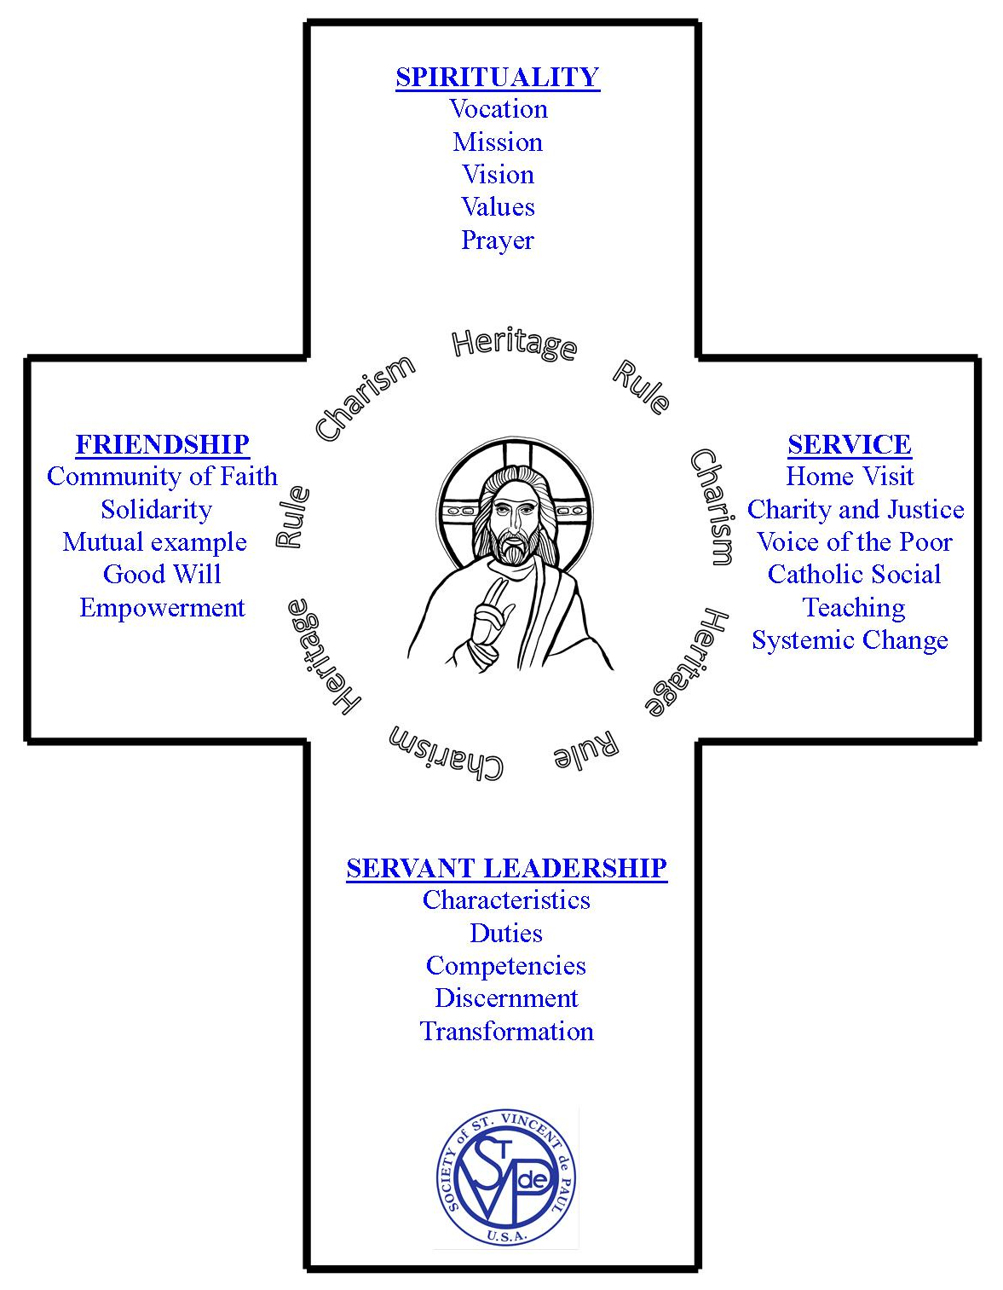

…Growing in Vincentian Leadership

The Vincentian Pathway

“A Life-Long Journey”

“It is essential that the Society continually promote the formation and training of its members and Officers, in order to deepen their knowledge of the Society and their spirituality, and to improve the sensitivity, quality and efficiency of their service to the poor…” (Rule: Part 1, 3.12)

The Vincentian Pathway is being offered as an opportunity for every Vincentian to engage in a life-long and on-going process of formation. This formation process is based on the Essential Elements of the Society (Spirituality-Friendship-Service) and Servant Leadership. As you walk your journey as a Vincentian you will encounter many delights and many challenges. Along the way you will grow and change. The Vincentian Pathway will help you to discover, develop, deepen and discern your Vincentian heart by forming your mind and attitude into a Vincentian way of serving.

To assist you in this formation process the four components of the Vincentian Pathway are inter-related and as you are challenged and grow through one component you will find challenge and growth through the others. This process will develop your Vincentian vocation and prepare you for the many and different Servant Leadership Roles that God may call you to assume throughout your Vincentian life. The four components are:
- Spirituality: will root you in a clear understanding of the Vincentian Spirituality which underlies your Vincentian vocation: mission, vision, values and prayer.
- Friendship: will provide you with the ways to gather the support, advice and encouragement you need for your Vincentian journey: community of faith, solidarity, mutual example, good will and empowerment.
- Service: will guide you to see exciting new ways to serve with a Vincentian heart, so that you will be able to strengthen your current service: home visits, charity and justice, voice of the poor, catholic social teachings, systemic change.
- Servant Leadership: will lead you to become a true Vincentian Servant Leader in the spirit of Jesus and our Founders: characteristics, duties, competencies, discernment, transformation.

Since 2000, through the Strategic Plan—Goal 1, Vincentian Spiritual Formation materials and programs have been developed and the Vincentian Pathway began transforming volunteers into Vincentians. On the Pathway, the Holy Spirit leads your Vincentian heart in the twist and turns of Discovering, Developing, Deepening and Discerning in your Vincentian vocation.

